
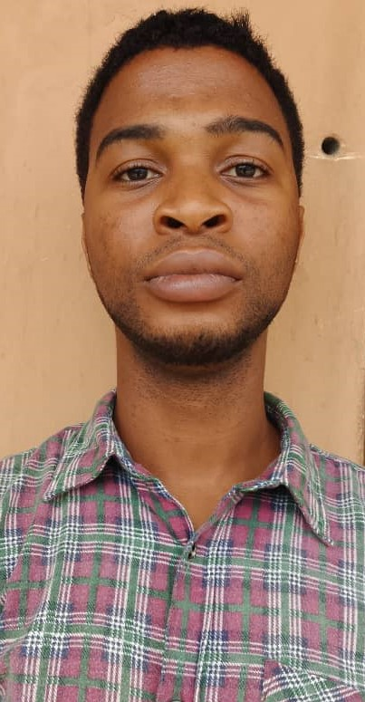
Pls Attach your
Passport
Photograph here!
PRE- EMPLOYMENT FORM (CONTRACT RESOURCE PERSONS)
PERSONAL INFORMATION
Iruke Chijindu Ugoeze
Name:
Surname First name Middle Name
07067583021
GSM No.: ___________________________ Email Address: __cjiruke@gmail.com_______________________

Marital status: Single ( y ) Married ( ) Sex: F ( y ) M ( ) Date of Birth: ___19/02/1998________
Aja, Lagos
Current Residential Address:
COURSE OF INTEREST/AVAILABILITY
Course(s)  Web design, Graphic Design | Availability:  Y  Immediately: Yes No  If No, kindly state when ________________________________

EDUCATION DATE
S/N | SCHOOLS ATTENDED (Starting from Tertiary Institution) | FROM | TO | QUALIFICATION OBTAINED/COURSE  (e.g., B.Sc. Computer Science)
1. | Abia State University | 2016 | 2019 | Geography and Planning
2.

TEACHING EXPERIENCE (Start from the most recent)
DATE
S/N | COMPANY NAME | FROM | TO | SUBJECT | MODE OF TRAINING
1. | Complete Computer Technology | 2022 |  | 2025
2.
MEDICAL
- Are you suffering from any illness or ailments that can affect your productivity adversely?

I hereby certify that the information contained in this application is accurate and correct. I understand that any omission or erroneous may be grounds for dismissal.

Iruke Chijindu
SIGNATURE & DATE: …………………………………………………………………………………………….

